**Assignment Day 8 | 9th December 2020**

**1. Create a simple shell script to tell the user about their session – they need to know: ● What their username is ● What the current date is ● What the time is ● What their current working directory is ● How many files they have in that directory ● What is the biggest file in their current directory**

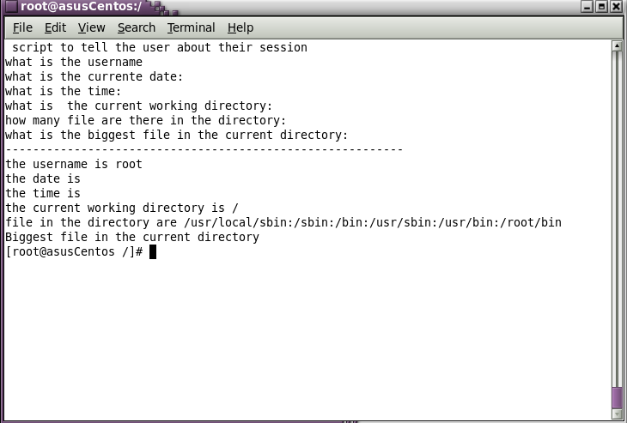

**Assignment 1 Create a directory with a few test files in it (the files can be empty). Now write a script that for every file in that directory you rename it to have an extension of today's date in YYYYMMDD format.**